Compound disturbance, additively modelled
Testing whether beetle mortality and fire severity interact, in the landscape and in the model, Darkwoods Conservation Area, British Columbia
Dr Seamus Murphy, ORCID-0000-0002-1792-0351, seamusrobertmurphy@gmail.com

Abstract
Compound disturbance is routinely described as an interaction and routinely modelled as a sum. This study separates them over a mountain pine beetle outbreak and the mixed-severity wildfire that followed it, in the southern Selkirk Mountains of British Columbia. Every beetle surface in the parent study descends from annual classifications clipped to the fire perimeter at source, and an unclipped provincial survey records attack outside the perimeter at a rate no lower than inside it, so any burned against unburned contrast measures the clip. Inside it, three records sharing no measurement pathway agree that attack peaks at moderate severity. The peak holds after conditioning on host cover and elevation, at 0.416 in log-odds against low severity; the fall at high severity does not. Refitting the parent study’s point process model with beetle by fire product terms returns an emphatic interaction under the Poisson likelihood it is fitted with, and none under inference respecting the clustering that study documents. The coefficients are identical, the intervals 2.4 to 7.6 times wider, and not one of sixteen excludes zero. These data cannot demonstrate a beetle by fire interaction; the confidence with which they appear to is the transferable result.

Introduction
Mountain pine beetle outbreak and wildfire increasingly overlap in the conifer forests of western North America, and the overlap is usually described in the language of interaction. Whether the description is earned is a separate question from whether it is common. Talucci and Krawchuk (2019) and Meigs et al. (2011) both frame the beetle to fire sequence as a modification of fuels and therefore of subsequent severity, and Krawchuk et al. (2020) place compound disturbance at the centre of the refugia concept. The claim that the agents interact is, in each case, a claim about a product rather than a sum.
The mechanism that would justify the claim is real and measurable. Beetle-killed foliage loses moisture and shifts in chemistry within a year of attack, and the flammability of that foliage rises accordingly (Jenkins et al. 2012). What has proved hard is carrying the mechanism up to the stand and the landscape. Simard et al. (2011) modelled crown fire behaviour through a beetle outbreak in lodgepole pine and found the probability of active crown fire no higher, and in the red stage lower, than in unattacked stands. Harvey et al. (2014) found the effect on burn severity contingent on outbreak stage rather than uniform, and small beside the effect of weather. Hart et al. (2015) found no relationship at all between outbreak extent and area subsequently burned across the western United States. The literature is therefore contested rather than empty, and what novelty there is in asking again rests on the particular landscape and on the treatment of confounding rather than on the question being new.
That contest is partly a contest about inference. Prior disturbance is not assigned at random, both agents track host abundance and terrain, and burn severity is measured on a raster whose cells are anything but independent. The literature on prior disturbance conditioning subsequent severity has taken this seriously: Stevens-Rumann et al. (2016), asking this study’s first question with fire in place of beetle across four large fires, fitted a spatially explicit autoregression precisely because burn severity is autocorrelated. The difficulty is that diagnosing dependence is easier than propagating it, and Magnussen et al. (2017) show in a different corner of forest science that omitting residual spatial autocorrelation leaves confidence intervals too narrow rather than merely imprecise. An interaction term is exactly the quantity that failure would flatter.
The parent study for this analysis (Murphy et al. 2026) modelled conifer regeneration across three four-hectare plots inside the 2015 Mt Midgeley burn, using classified Landsat surfaces for burn severity and for red-stage beetle mortality. Its abstract describes the additive effects of increasing beetle to fire disturbance interactions. Its model, however, enters red attack, grey attack and burn severity as additive main effects with no product term among them. The two statements are not the same statement, and the ambiguity was noticed at the time without being resolved.
This study asks the two questions that separation implies.
The first is whether prior beetle mortality is associated with subsequent burn severity in this landscape. The outbreak ran from 2005 to 2014 and the fire burned in 2015, so the causal arrow runs one way only, from beetle to fire, and never the reverse.
The second is whether a beetle by fire product term is supported in a model of regeneration. The test is direct: refit the published point process model with the product term and compare it against the published additive fit. The wording matters and is kept narrow throughout. A designed factorial can license the language of interaction outright, as Bansal et al. (2014) do in crossing burn severity with canopy cover and reporting effects that are conditional by construction. An observational fit over ground that neither treatment nor randomisation touched cannot, and the convention in this literature is accordingly more careful: Estabrook et al. (2025) describe burn severity as contingent on weather and then fit weather as main effects. This study reports whether the product term is retained and what interval its coefficient carries. It does not report that the two agents interact.
The first question turned out to require a prior question, which is whether the surfaces that would answer it can answer it. Section 3 reports that check. It is negative, it is decisive, and it changes the shape of question one before any ecology is attempted.
The second question turned out to require a prior question too, and a less obvious one: not whether the data can support a product term, but whether the likelihood used to fit it can be trusted to say. Section 5 reports that the product term is emphatic under the likelihood the parent study fits and absent under inference that accounts for the clustering the parent study itself documents. The coefficients are the same either way. That gap, rather than either question’s ecology, is what this paper carries beyond the landscape it was measured in.

Materials and methods

Study area
The Darkwoods Conservation Area lies in the southern Selkirk Mountains of southeastern British Columbia. A mountain pine beetle outbreak affected the property through the decade to 2014, and the Mt Midgeley wildfire burned part of it in 2015, producing a mixed-severity mosaic. The beetle to fire interval across the burned area ranges from one to eleven years with a median of seven (Murphy et al. 2026).

Attack chronology
An association between a prior disturbance and a later one is only as good as the dating of the prior one. Studies of this kind normally say so: Kulakowski and Veblen (2006) date a nineteenth-century outbreak from growth releases in surviving non-host trees, Meyer et al. (2016) reconstruct pre-attack structure by returning recently dead trees to the live tally, and Estabrook et al. (2025) discuss how a forest inventory’s remeasurement interval degrades its record of pre-fire condition.
Here the dating instrument is the annual Landsat classification. There are 9 annual files, and attack in a given cell is the year of the first file that records it. That gives a nominal resolution of one year and a real resolution that is coarser, for three reasons the manuscript can bound but not remove.
Table 1: The annual classifications that date beetle attack, and the aerial-survey code the grey-stage union is built from. There is no file for the missing year, and the two most recent files carry none of the code at all, so the window that can be dated closes earlier than the file list suggests.
Year | Cells coded | Within window
2005 | 534 | yes
2006 | 1530 | yes
2007 | 573 | yes
2008 | 0
2009 | 324 | yes
2010 | 0
2011 | 137 | yes
2013 | 0
2014 | 0

Red-attack foliage is detectable for roughly one to three years after the attack that produced it (Wulder et al. 2006), so a first detection dates the crown-colour change rather than the attack, and places it within a window rather than on a year.
The series is also thinner than a count of its files suggests, in three separate ways. 9 files exist, but there is none for 2012. The two most recent, for 2013 and 2014, carry the aerial-survey code in not one cell, because they are a different product on a different code set and contribute nothing to the union; the window therefore closes at 2011 rather than at 2014, and an analyst who read the file list as a 2005 to 2014 series would be wrong. And two files inside the window, for 2008 and 2010, are likewise empty of the code. So the grey-stage union rests on 5 annual observations spread across a 7-year window, not on 7 of them. The assertion above fails the render if any year outside the window ever begins to contribute.
The response used throughout is that union, and it is deliberately undated: it records whether a cell was ever attacked across 2005 to 2011, not when. Given two empty years inside the window and a detection window of one to three years on either side of each observation that is not empty, that is the honest way to use these surfaces.
Nothing in this study therefore turns on the beetle-to-fire interval, which these surfaces do not resolve at anything finer than the window itself. The analysis asks whether a cell carried attack before the fire, not how long before.

Classified surfaces
Table 2: Footprints of the local classified surfaces against the terrain grid. Every disturbance surface is confined to a rectangle of roughly eight square kilometres; the terrain grid covers thirty-four times that area.
Surface | Rows | Cols | Cell (m) | Width (km) | Height (km) | Extent (km2)
Elevation, terrain grid | 695 | 639 | 25.11 | 16.05 | 17.45 | 280.09
Beetle red stage | 135 | 66 | 29.56 | 1.95 | 3.99 | 7.78
Beetle grey stage, corrected | 135 | 66 | 29.56 | 1.95 | 3.99 | 7.78
Beetle grey stage, deprecated | 135 | 66 | 29.56 | 1.95 | 3.99 | 7.78
Beetle continuous (spatstat) | 52 | 47 | 29.49 | 1.39 | 1.53 | 2.13
Burn severity, classified | 134 | 66 | 30.00 | 1.98 | 4.02 | 7.96
Beetle by fire intersection | 136 | 67 | 29.56 | 1.98 | 4.02 | 7.96

The fire perimeter encloses 4.8 km². The beetle red-stage raster spans a rectangle of 7.78 km² around it, so the raster carries roughly 2.98 km² of ground outside the burn on which beetle attack could in principle have been mapped. The terrain grid covers 280 km² of the same landscape and shows what surrounds the burn.

Severity class decoding
The classified severity raster carries integer codes that are not ordered by severity, and the ordering matters to every table that follows. It is established here from the three binary class masks rather than assumed.
Table 3: Decoding the classified burn severity raster against its own binary class masks, and against the fire perimeter. The integer codes are not in severity order. Code 16 falls inside the perimeter but in none of the three severity classes.
Class | Code | Cells | Inside perimeter (%)
Outside perimeter | 0 | 3514 | 0.1
Inside perimeter | 16 | 1268 | 100.0
Low | 32 | 2144 | 99.9
Moderate | 34 | 1383 | 99.8
High | 1 | 535 | 100.0

Code 1 is high severity and code 34 is moderate, so a table built on the numeric order of the codes would report the two most severe classes the wrong way round. Code 16 is the class that no severity mask claims: 1,268 cells lying inside the fire perimeter but assigned to none of high, moderate or low.

Independent survey record
The provincial Aerial Overview Survey is the operational record of forest health in British Columbia. Observers sketch-map damage annually from fixed-wing aircraft and label each polygon by year, causal agent, severity class and host species (Province of British Columbia, Ministry of Forests 2026). It is coarse, it is observer data, and its errors are positional and perceptual rather than spectral. That last property is what makes it useful here: whatever is wrong with it is uncorrelated with the Landsat classification whose footprint is under test. Over the terrain grid the survey holds 608 damage polygons of all agents and years, of which 276 are mountain pine beetle within the 2005 to 2014 outbreak window used here.

Spatial coverage
Everything the study analyses sits inside one small burn, and the three nested scales below are what that means in practice. The regional panel carries the international border because the provincial survey used as the independent record stops there, and so does any comparison drawn from it.
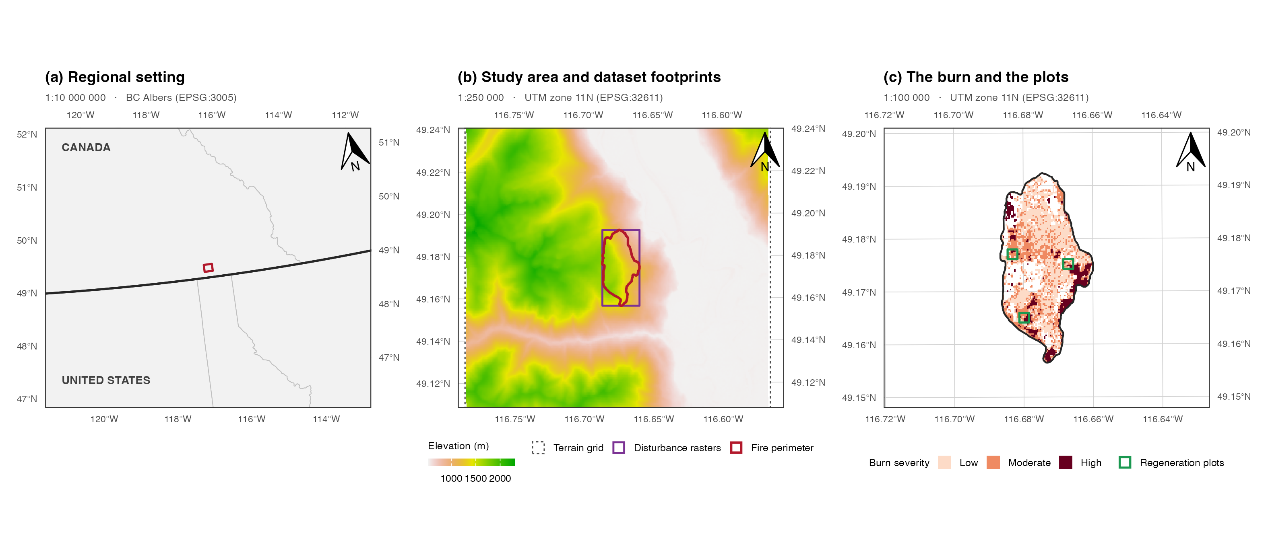
Figure 1: The study area at three nested scales. (a) Regional setting, with the Canada and United States border and provincial and state boundaries. (b) The terrain grid, the rectangle shared by every disturbance raster, and the fire perimeter inside it. (c) The burn itself with its classified severity and the three four-hectare regeneration plots that carry the point pattern of Section 5. Each panel is drawn to the stated representative fraction at the reproduction width given in the text, carries a true-north arrow, and is bounded by a WGS 84 graticule labelled on all four sides.
The scales are 1:10 000 000, 1:250 000 and 1:100 000, each exact at a panel 2.70 inches wide. That width is measured off the assembled figure rather than assumed, and the extents are then rebuilt at it, so the ratios printed on the panels are the ratios the panels are drawn to and not the ratios they were asked for. Reproduced at any other width the ratios change in proportion, which is the ordinary caveat on a printed representative fraction and the reason the panel width is stated rather than left to be inferred. Panels (b) and (c) are in the UTM zone 11N grid the analysis works in; panel (a) is in BC Albers, an equal-area projection appropriate to the province. All three are bounded by a WGS 84 graticule.
Panel (b) is the whole of the provenance problem in one frame: the terrain grid covers 280 km², every disturbance raster shares a footprint of 7.78 km², and the fire perimeter inside it encloses 4.8 km². Terrain is mapped across the landscape and disturbance only in a rectangle drawn around the fire. Section 3 shows that the beetle surfaces stop tighter still.

Surface provenance
The scoping for this study reported a contingency table in which beetle red attack rose from near zero in unburned forest to roughly a fifth of cells at moderate burn severity. Taken at face value that is a strong compound-disturbance signal. It is also exactly the pattern a clipped raster would manufacture, and the clip is the first thing to rule out.

Perimeter clipping
The annual rasters carry data on 0.3 per cent of the 3,429 cells lying outside the fire perimeter, and nodata on the rest. Every beetle surface in the study descends from those files, so every one of them inherits the boundary: the corrected grey union places 1 of its 1541 cells outside the perimeter and the published red-stage surface places 0 of its 493.
The clip is in the source data, not in any downstream step. All 9 annual files carry an identical nodata count of 3,423 cells, 3,419 of which lie outside the perimeter, and the boundary it traces is the fire perimeter, which is a shape no property of beetle ecology would produce. Whoever prepared the time series clipped it to the burn before the classification that used it was ever run.
Table 4: Where each beetle surface stops, against the fire perimeter, on the native beetle grid. The annual rasters carry nodata over almost the whole area outside the perimeter, and the two derived surfaces inherit it.
Surface | Cells present | Inside | Outside | Note
Annual rasters | 5487 | 5477 | 10 | nodata over the rest
Grey stage | 1541 | 1540 | 1 | union of code 44
Red stage | 493 | 493 | 0 | substituted for a missing layer

Nested masks
The red and grey surfaces do not stop in the same place, and the difference matters.
SEV <- resample(sev, red, method = "near")
CLASSIFIED <- vals(SEV) %in% CODE_OF[SEV_LEVELS]
## The three regions are not nested: 22 cells carry a classified severity code
## and fall outside the rasterised perimeter, so these masks are kept as written
## rather than derived from one another by grouping.
REGION <- list(`Outside the fire perimeter` = !INPER,
`Inside perimeter, unclassified severity` = INPER & !CLASSIFIED,
`Inside the classified severity footprint` = CLASSIFIED)
pct_by_region <- function(v) round(100 * vapply(REGION, function(m) mean(v[m]), numeric(1)), 1)
NEST <- tibble(Region = names(REGION),
Cells = vapply(REGION, sum, integer(1)),
`Annual data (%)` = pct_by_region(OBS),
`Grey attack (%)` = pct_by_region(GREY_HIT),
`Red attack (%)` = pct_by_region(RED_HIT))
show(NEST, "tbl-nested", "lrrrr")
Table 5: The two surfaces against the classified severity footprint. Grey attack is recorded throughout the perimeter; red attack is confined to the three classified severity classes and is absent from the cells inside the perimeter that no class mask claims.
Region | Cells | Annual data (%) | Grey attack (%) | Red attack (%)
Outside | 3429 | 0.3 | 0.0 | 0.0
Inside unclassified | 1367 | 99.7 | 33.1 | 0.0
Inside classified | 4136 | 99.5 | 26.3 | 11.9

Inside the perimeter but outside the classified severity footprint, the annual rasters are 99.7 per cent observed and the corrected grey union records attack in 33.1 per cent of cells. The published red-stage surface records it in 0 per cent. That contrast cannot be ecological: the same ground, in the same years, is either a third attacked or not attacked at all depending on which derivative of the same annual files is consulted.
So there are two clips, one inside the other. The annual series is clipped to the fire perimeter, and Beetle.Outbreak.RedStage.tif is confined more tightly still, to the ground where burn severity was classified. The narrower one is an accident of substitution rather than a decision: the layer the published analysis intended to use, mpb_red_na.tif, is missing from the repository, and Beetle.Outbreak.RedStage.tif was put in its place (Murphy 2026b).

Independent corroboration
If the zeroes are ecological, the provincial survey should also find little beetle attack outside the burn. If they are clipping, the survey should find as much there as anywhere. The small sliver of annual data that does extend beyond the perimeter provides a second, internal check on the same question.
Table 6: The two local surfaces against the independent Aerial Overview Survey, by burn severity class. Local rates are computed only over cells the annual rasters actually observe. The survey finds no shortage of beetle attack outside the burn, and neither does the small observed sliver of the local data.
Class | Cells | Observed (%) | Grey (%) | Red (%) | Survey (%) | Elevation (m)
Outside | 3429 | 10 (0.3) | 10.0 | 0.0 | 40.4 | 1190
Inside unclassified | 1367 | 1363 (99.7) | 33.2 | 0.0 | 51.8 | 1442
Low severity | 2158 | 2158 (100.0) | 20.8 | 6.3 | 24.5 | 1367
Moderate severity | 1403 | 1403 (100.0) | 34.6 | 20.7 | 40.6 | 1449
High severity | 553 | 553 (100.0) | 27.7 | 12.1 | 33.1 | 1408

The shaded row carries the argument. Outside the fire perimeter the survey records 40.4 per cent of the ground as attacked, a rate no lower than anything inside the burn and higher than two of the three burned classes. The local surfaces report nothing there at all, and they report nothing because they see nothing: of 3,429 cells outside the perimeter the annual rasters observe 10.
That figure is worth stating plainly rather than converting to a rate. The local record is not sparse outside the burn, it is very nearly absent, and 10 cells cannot corroborate or contradict anything. The comparison therefore rests on the survey alone, which is sufficient: an independent census of the same ground in the same years finds beetle attack there in ordinary abundance. The zero the published red-stage surface reports outside the burn is a statement about the extent of the file, not about the forest.
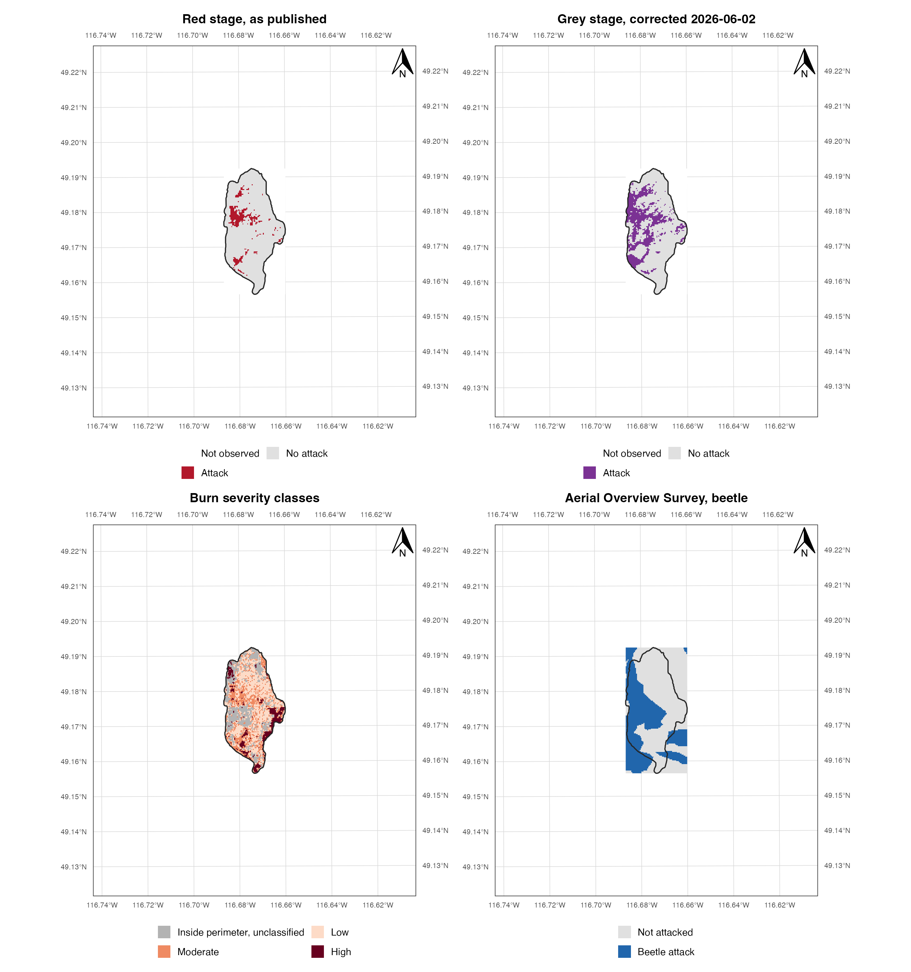
Figure 2: The clip, mapped, at 1:50 000 in UTM zone 11N (EPSG:32611) with a WGS 84 graticule labelled on all four sides. Top left, the published red-stage surface, which stops at the classified burn. Top right, the corrected grey-stage union, which reaches the fire perimeter and stops there. Bottom left, the burn severity classes. Bottom right, the independent Aerial Overview Survey, which does not stop at anything. The unburned ground in the two upper panels is empty because it was never observed, not because it was never attacked.

Methodological implications
The clip destroys any comparison that crosses the fire perimeter and leaves untouched any comparison made entirely inside it. The three severity classes all sit within the perimeter and are observed at better than 100 per cent, so the clip cannot generate differences among them.
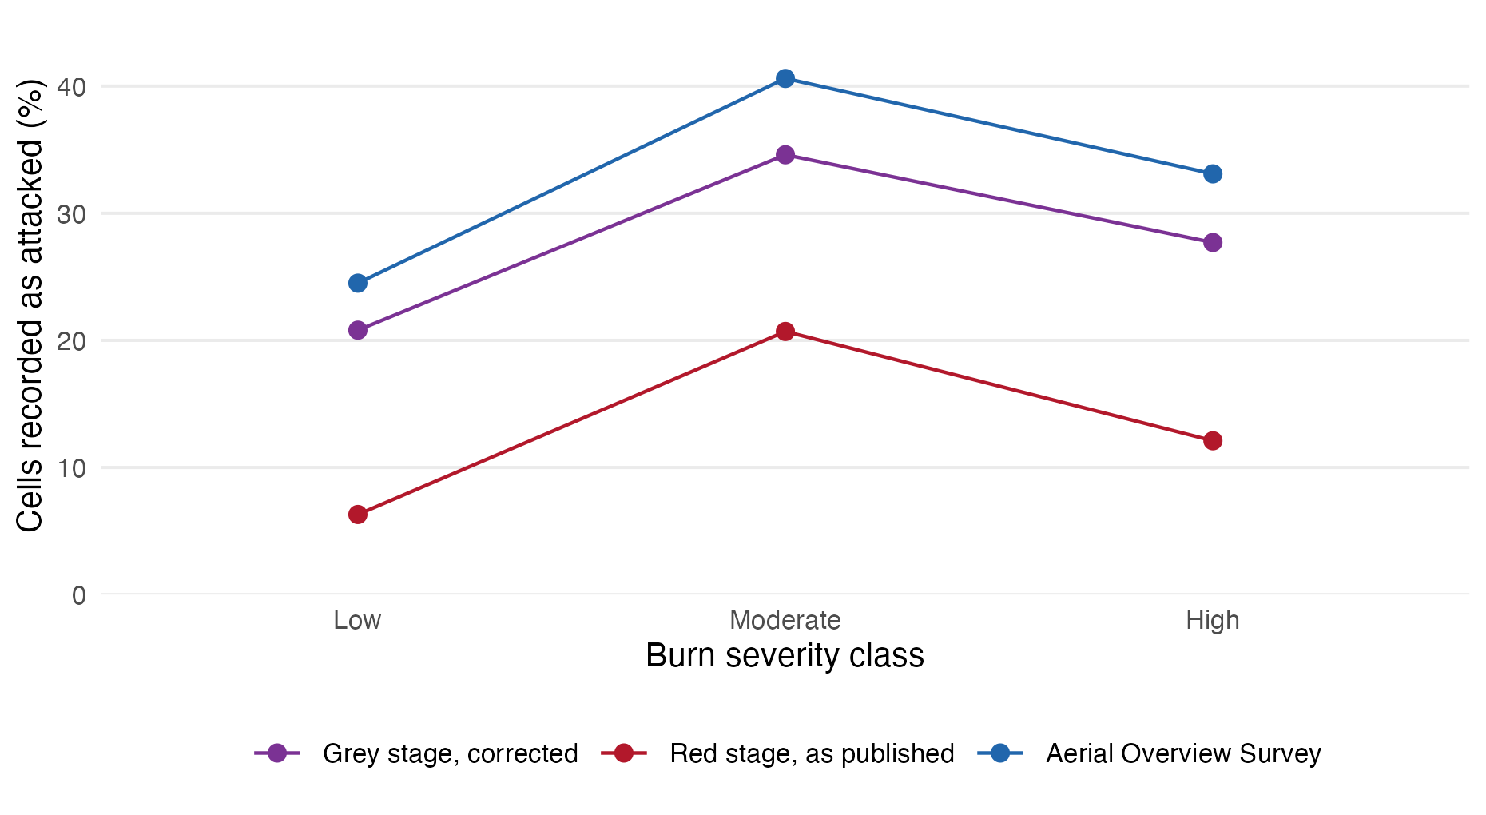
Figure 3: Beetle attack across burn severity within the fire perimeter, in the two local surfaces and in the independent survey. The three records share no common measurement pathway and all three peak at moderate severity. Point labels give the number of cells in each class.
Three records agree on the shape. The corrected grey union runs 20.8, 34.6, 27.7 per cent across low, moderate and high severity, the published red-stage surface 6.3, 20.7, 12.1, and the independent survey 24.5, 40.6, 33.1. All three peak at moderate and fall at high, and the assertion above fails the render if they ever stop agreeing. The two local surfaces share a measurement pathway with each other but not with the survey, so the agreement is not one instrument repeating itself.
That agreement is not yet evidence about fire. The elevation column is the reason. Moderate severity occupies the highest mean elevation of the three burned classes at 1449 m, and the companion refugia analysis of this landscape finds beetle attack peaking near 1,430 m for reasons that have nothing to do with fire (Murphy 2026a). A severity gradient that is also an elevation gradient will reproduce the beetle elevation optimum whether or not severity matters. Conditioning on host abundance and on elevation is therefore the first task of the next phase, not a robustness check appended to it.

Gradient conditioning & framing
Three records agreeing that attack peaks at moderate severity is not yet evidence that severity is doing the work. Both agents track host abundance and topography, and lodgepole-rich, mid-elevation stands are both more attackable and more burnable, so an apparent association between them may be host distribution seen twice. This section conditions on both.
The frame is 5,413 cells, of which 1,518 carry grey-stage attack. Lodgepole is present on 64 per cent of them.

Covariate collinearity
Table 7: Attack, host cover and elevation by burn severity class, and the crude contrast between stands carrying lodgepole and stands without it.
Stratum | Cells | Attacked (%) | Lodgepole (%) | Elevation (m)
High severity | 553 | 27.7 | 18.1 | 1408
Low severity | 2158 | 20.8 | 17.2 | 1367
Moderate severity | 1403 | 34.6 | 24.4 | 1449
Unclassified | 1299 | 33.2 | 20.2 | 1442
Lodgepole absent | 1973 | 15.3 | 0.0 | 1258
Lodgepole present | 3440 | 35.3 | 31.3 | 1498

The crude host contrast is large: 35.3 per cent of cells carrying lodgepole were attacked against 15.3 per cent of cells without it, the same direction and roughly the same magnitude the companion study finds at landscape extent. But lodgepole cover and elevation correlate at 0.52 across this frame, and that is the difficulty. At landscape extent the two can be separated because the elevation gradient runs far enough for pine-poor ground to occur at every height. Inside an eight square kilometre burn it does not.

Conditioned coefficients
Table 8: Burn severity coefficients on grey-stage attack, as log-odds against low severity, crude and then conditioned on host presence and elevation. Intervals are spatial block bootstrap percentiles at 500 m blocks. An interval that excludes zero is marked.
Model | Term | Estimate | Interval
Severity only | sevModerate | 0.705 | [0.357, 0.997] | clears zero
Severity only | sevHigh | 0.378 | [-0.405, 1.133]
Severity only | sevUnclassified | 0.639 | [-0.062, 1.157]
+ host + elevation | sevModerate | 0.416 | [0.101, 0.731] | clears zero
+ host + elevation | sevHigh | 0.286 | [-0.476, 1.002]
+ host + elevation | sevUnclassified | 0.328 | [-0.241, 0.946]
+ host + elevation | host | 0.186 | [-0.474, 0.855]
+ host + elevation | ec | 0.424 | [0.247, 0.674] | clears zero
+ elevation squared | sevModerate | 0.403 | [0.082, 0.736] | clears zero
+ elevation squared | sevHigh | 0.277 | [-0.482, 1.021]
+ elevation squared | sevUnclassified | 0.306 | [-0.291, 0.929]
+ elevation squared | host | 0.196 | [-0.457, 0.923]
+ elevation squared | ec | 0.415 | [0.243, 0.649] | clears zero
+ elevation squared | I(ec^2) | 0.023 | [-0.047, 0.120]

Three things follow, and only the first is a positive result.
Moderate severity survives conditioning, attenuated. The crude coefficient of 0.705 falls to 0.416 once host presence and elevation are in the model, so roughly 41 per cent of the crude association is host and terrain. What remains still clears the block interval. Adding a quadratic elevation term moves it hardly at all.
High severity is never distinguishable from low. Its interval spans zero in every specification. The non-monotone shape that all three records trace is therefore a claim the data supports at its peak and not at its fall: attack is elevated at moderate severity, and whether it declines at high severity cannot be settled from 553 cells. Do not report a demonstrated decline at high severity.
Host cover cannot be separated from elevation here, and elevation wins. Entered alongside elevation, host presence carries an interval that spans zero comfortably, despite the crude contrast of 35.3 against 15.3 per cent. Elevation is the only covariate whose interval excludes zero in every specification. This does not contradict the companion study’s finding that host governs the landscape pattern; it means that at this extent the question cannot be asked, because the two predictors are 0.52 correlated and the burn is too small to break the tie.
EL_RANGE <- range(FR$elev)
b1 <- gv(M_QUAD, "ec"); b2 <- gv(M_QUAD, "I(ec^2)")
PEAK <- 1400 + 100 * (-b1 / (2 * b2))
## Estimate with its interval, by term. gv() already did the estimate half.
term_ci <- function(m, tm) {
r <- m[m$Term == tm, ]
sprintf("%.3f %s", r$Estimate, ci_txt(r$Lower, r$Upper))
}
ELT <- tibble(
Quantity = c("Elevation range spanned by the burn",
"Linear elevation, log-odds per 100 m",
"Quadratic elevation term",
"Implied optimum of the fitted quadratic",
"Landscape-scale optimum, companion study"),
Value = c(sprintf("%.0f to %.0f m", EL_RANGE[1], EL_RANGE[2]),
term_ci(M_ADJ, "ec"),
term_ci(M_QUAD, "I(ec^2)"),
sprintf("%.0f m", PEAK),
"about 1,430 m"))
show(ELT, "tbl-elev", "ll")
Table 9: The elevation term inside the burn, against the landscape-scale form the companion study reports. The quadratic term is negligible and its implied optimum falls far outside the elevation range the burn spans, so within this clip the relationship is monotone.
Quantity | Value
Elevation range spanned by the burn | 872 to 1747 m
Linear elevation, log-odds per 100 m | 0.424 [0.247, 0.674]
Quadratic elevation term | 0.023 [-0.047, 0.120]
Implied optimum of the fitted quadratic | 503 m
Landscape-scale optimum, companion study | about 1,430 m

The companion study finds beetle attack peaking near 1,430 m across 1,776 m of relief (Murphy 2026a). Inside this burn the fitted optimum lands at 503 m, far below anything the clip contains, which is the arithmetic way of saying the quadratic has no support here: over 874 m of truncated gradient the relationship is monotone increasing. The landscape-scale hump is not contradicted, it is invisible. An analyst working only inside this perimeter would report that beetle attack rises with elevation without limit.

Block bootstrap inference
Moran’s I on the response is high and the residuals stay dependent well beyond a single cell, so naive standard errors would be meaningless. The block bootstrap fixes that, but the block size is not free: blocks must be large enough to contain the dependence and numerous enough to resample. Over a burn this size the two requirements collide.
## The 500 m run is M_ADJ exactly: same formula, same blocks, same seed, same
## draws. Reusing it saves a redundant 400-replicate bootstrap. Each block_boot
## call seeds itself and draws nothing beforehand, so this cannot perturb the
## RNG stream of any other run.
SWEEP_RAW <- lapply(BLOCK_SWEEP, function(m) {
fit <- if (m == BLOCK_M) M_ADJ else block_boot(F_ADJ, side_m = m)
fit |> filter(Term == "sevModerate") |> mutate(`Block side (m)` = m)
}) |> bind_rows()
## Numbers stay numbers. Formatting is a leaf, never an input: the previous
## version formatted these bounds into a string and regex-parsed them back.
SWEEP <- SWEEP_RAW |>
transmute(`Block side (m)`, Blocks = K, Estimate = round(Estimate, 3),
Interval = ci_txt(Lower, Upper),
` ` = ifelse(clears(Lower, Upper), "clears zero", "spans zero"))
## The correlogram that justifies the block sizes tried.
res <- residuals(glm(F_ADJ, binomial, FR), type = "pearson")
set.seed(7); ii <- sample(nrow(FR), 3000)
## dist() enumerates pairs in the same column-major order lower.tri() selects,
## so the two vectors stay aligned. The previous form built four dense 3000 by
## 3000 matrices to read two triangles out of them.
dd <- as.vector(dist(cbind(FR$row[ii], FR$col[ii]))) * RES_M
rr <- outer(res[ii], res[ii], "*") / var(res[ii])
rr <- rr[lower.tri(rr)]
bins <- cut(dd, c(0, 100, 200, 300, 500, 800, 1200, Inf))
CORR <- tibble(`Lag (m)` = levels(bins),
`Residual correlation` = round(as.numeric(tapply(rr, bins, mean)), 3))
invisible(keep(SWEEP, "fig-blocks"))
FIG_BLK <- ggplot(SWEEP_RAW, aes(factor(`Block side (m)`), Estimate)) +
geom_hline(yintercept = 0, linetype = "22", colour = "grey40") +
geom_linerange(aes(ymin = Lower, ymax = Upper), linewidth = 0.55, colour = "#7b3294") +
geom_point(size = 2.2, colour = "#7b3294") +
geom_text(aes(y = Upper, label = paste(K, "blocks")), vjust = -0.9, size = 2.5,
colour = "grey30") +
scale_y_continuous(expand = expansion(mult = c(0.08, 0.18))) +
labs(x = "Block side (m)", y = "Log-odds, moderate against low severity") +
theme(panel.grid.major.x = element_blank())
BLK_PATH <- file.path("..", "03.outputs", "PNG", "fig-blocks.png")
ggsave(BLK_PATH, FIG_BLK, width = 5.6, height = 3.2, dpi = 300, bg = "white")
knitr::include_graphics(BLK_PATH)
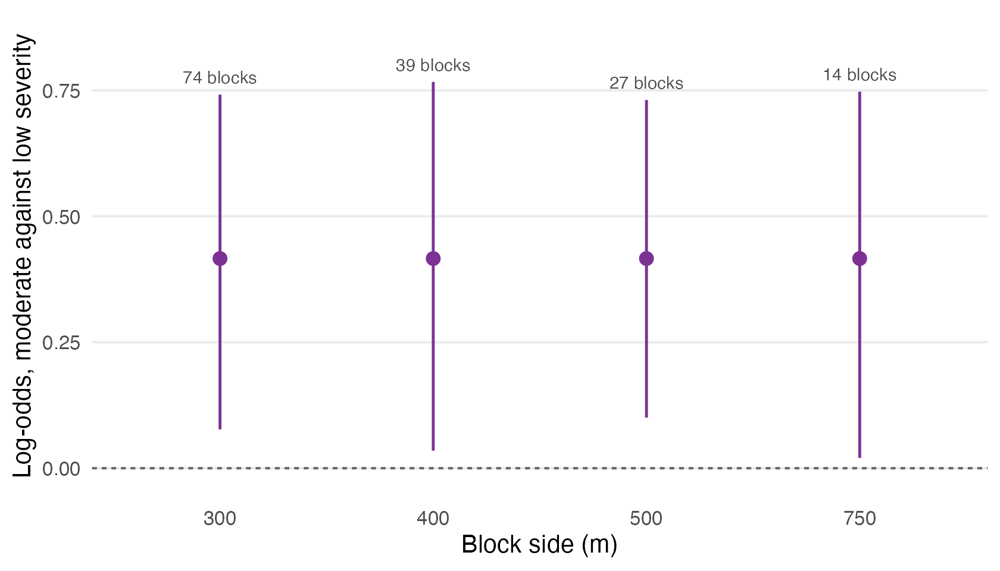
Figure 4: The moderate-against-low severity coefficient under block bootstraps of increasing block size. The estimate is fixed; only the interval changes, and the number of blocks each size affords is printed above it. The extent caps the largest usable block, not the conclusion.
Residual dependence falls from 0.394 within 100 m to 0.057 by 500 m, so a 500 m block contains most of it. Figure 5 plots this alongside the same measurement inside the regeneration plots, because the two scales meet the same obstacle and it is easier to see them together. The burn spans about 4.0 by 2.0 km, which affords 27 blocks at that size and only 14 at 750 m. The companion study uses roughly 1 km blocks over a landscape that affords hundreds; here 1 km would afford eight, which is not a bootstrap.
## Let the sweep state its own conclusion rather than asserting one that a
## refit might quietly invalidate.
N_CLEAR <- sum(clears(SWEEP_RAW$Lower, SWEEP_RAW$Upper))
WEAKEST <- SWEEP_RAW$`Block side (m)`[which.min(SWEEP_RAW$Lower)]
WEAK_LO <- min(SWEEP_RAW$Lower)
So the moderate-severity result is reported with its dependence stated. It clears the interval at all 4 block sizes tried, so the conclusion does not rest on a convenient choice of block, and it is weakest at 750 m where the lower bound sits at 0.020 on 14 blocks. That is the honest edge of what this extent supports.
The general point is not a robustness check that the study passed. It is the study’s own subject matter arriving in its own inference: the extent that makes the compound-disturbance question askable at all is the same extent that decides how firmly it can be answered, and an analyst who reported only the 500 m interval would be concealing that the margin at 750 m is a hair’s breadth.

Regeneration interaction
The first question asked whether beetle and fire are associated on the ground. This one asks whether their effects on what grew back multiply or merely add. It is the question the parent study’s title and abstract assert an answer to and its model never puts to the test, and unlike question A it is untouched by the perimeter clip, because the seedling point pattern lies wholly inside the burn and every cell entering the model is equally masked.
The test is direct. Refit the published model with the beetle by fire product term and compare.

Model specification
The parent study models conifer regeneration as an inhomogeneous point process over three four-hectare plots, fitted by the Berman-Turner device: the seedlings enter as data points, a regular grid of dummy points carries the quadrature weights, and the trend is estimated by weighted Poisson regression on the pooled set (Baddeley and Turner 2000). The specification is reproduced here exactly, including its quadrature spacing, so that anything that changes when the product term is added is the product term and not a difference of setup.
## PLOT_SF was read for fig-location; reading the three shapefiles a second time
## here would risk the two copies drifting apart.
WIN <- st_union(PLOT_SF)
WIN_HA <- as.numeric(st_area(WIN)) / 1e4
## The seedling frame. Three counts are in circulation for this point pattern
## and the difference between them is a species filter, not a rival survey, so
## it is derived here rather than chosen.
SEED_ALL <- st_read(dpath("seedlings/Seedlings.shp"), quiet = TRUE)
SPECIES <- c("0", "1", "2", "3", "4", "5", "7") # the seven-species lookup of the parent study
IN_LUT <- as.character(SEED_ALL$species) %in% SPECIES
SEED <- SEED_ALL[IN_LUT, ]
N_RAW <- nrow(SEED_ALL); N_DROP <- sum(!IN_LUT); N_SEED <- nrow(SEED)
## Every retained seedling falls inside the plot windows, so the species filter
## is the whole of the difference between the two counts.
stopifnot(N_RAW - N_DROP == N_SEED,
all(lengths(st_within(SEED, WIN)) > 0))
## The quadrature grid, at the spacing the published fit used.
bx <- st_bbox(WIN)
GR <- expand.grid(x = seq(bx["xmin"] + PP_DX/2, bx["xmax"], by = PP_DX),
y = seq(bx["ymin"] + PP_DX/2, bx["ymax"], by = PP_DX))
GR <- GR[lengths(st_within(st_as_sf(GR, coords = c("x", "y"), crs = 32611), WIN)) > 0, ]
## The covariates of the published trend, read from the same files it read. The
## grey-stage layer is the corrected union of 2 June 2026, which is the raster
## the parent study's own final refit uses; the legacy layer it replaced is
## discussed in sec-ppsupport.
PP_RAS <- list(
Aspect = rast(dpath("terrain_environment/Aspect.utm.tif")),
RIX = rast(dpath("terrain_environment/Rutm.tif")),
Wind = rast(dpath("terrain_environment/Wind.utm.tif")),
MPB_G = rast(file.path(GREY_FIX, "rasters", "mpb_grey_corrected.tif")),
MPB_R = rast(dpath("beetle_stages/Beetle.Outbreak.RedStage.tif")),
Fire_H = rast(dpath("fire_severity/Fire.High.NDBR.tif")),
Fire_L = rast(dpath("fire_severity/Fire.Low.NDBR.tif")),
Fire_M = rast(dpath("fire_severity/Fire.Med.NDBR.tif")))
PP_BINARY <- c("MPB_G", "MPB_R", "Fire_H", "Fire_L", "Fire_M")
at_points <- function(xy) {
pt <- vect(as.matrix(xy), type = "points", crs = "EPSG:32611")
z <- lapply(PP_RAS, function(r) as.numeric(terra::extract(r, project(pt, crs(r)))[, 2]))
## Sentinels, as the published script treats them: -1 is flat ground on the
## aspect surface and -999 is missing wind. Beers northness on the remainder.
z$Aspect <- cos(ifelse(z$Aspect == -1, NA, z$Aspect) * pi / 180)
z$Wind <- ifelse(z$Wind <= -990, NA, z$Wind)
for (nm in PP_BINARY) z[[nm]] <- ifelse(is.na(z[[nm]]), NA, as.numeric(z[[nm]] == 1))
as.data.frame(z)
}
SXY <- st_coordinates(SEED)[, 1:2]
QXY <- as.matrix(GR)
PD <- at_points(SXY); PD$SS_dist <- as.numeric(SEED$distance_m)
PQ <- at_points(QXY)
## Seed source distance is recorded per seedling, not per cell, so the published
## fit carries it to the quadrature points by nearest neighbour. Reproduced here
## because dropping it would change every other coefficient.
PQ$SS_dist <- PD$SS_dist[FNN::get.knnx(SXY, QXY, k = 1)$nn.index[, 1]]
PD$x <- SXY[, 1]; PD$y <- SXY[, 2]; PD$data_pt <- TRUE
PQ$x <- QXY[, 1]; PQ$y <- QXY[, 2]; PQ$data_pt <- FALSE
PP <- rbind(PD, PQ)
## Berman-Turner: quadrature weight is the cell area at a dummy point and a
## negligible constant at a data point, and the response is the reciprocal of
## the weight where a point was observed and zero elsewhere.
PP$w <- ifelse(PP$data_pt, 1, PP_DX^2)
PP$yy <- ifelse(PP$data_pt, 1 / PP$w, 0)
F_ADD <- yy ~ SS_dist + Aspect + RIX + Wind + MPB_G + MPB_R + Fire_H + Fire_L
F_PROD <- update(F_ADD, . ~ . + MPB_G:Fire_H + MPB_G:Fire_L +
MPB_R:Fire_H + MPB_R:Fire_L)
PP <- PP[complete.cases(PP[, all.vars(F_ADD)[-1]]), ]
N_DATA <- sum(PP$data_pt); N_DUMMY <- sum(!PP$data_pt)
## The severity class of each point, needed for the support table and for the
## four-level specification. Built from the class masks, not from the composite
## severity code, which is the encoding trap of sec-decode.
PP$Severity <- factor(
with(PP, ifelse(Fire_H == 1, "High", ifelse(Fire_M == 1, "Moderate",
ifelse(Fire_L == 1, "Low", UNCLASSED)))),
levels = c(SEV_LEVELS, UNCLASSED))
stopifnot(!any(is.na(PP$Severity)))
The shapefile holds 3,912 points, of which 46 carry a species code outside the seven-species lookup the parent study used, leaving 3,866, all inside the plot windows. The two counts in circulation therefore differ by a species filter and nothing else; a third, 3,886 in the published abstract, matches neither and is reproduced by no filter tried here. The fit uses 3,866 data points against 1,282 quadrature points over 12.69 ha.

Fit reproduction
Nothing below is worth reading unless the additive fit reproduces. It does, to the precision the published table is printed at.
## glm.fit on a prebuilt model matrix, as in sec-conditioned: identical
## arithmetic to formula glm and fast enough to bootstrap.
pfit <- function(X, idx) {
f <- suppressWarnings(glm.fit(X[idx, , drop = FALSE], PP$yy[idx],
weights = PP$w[idx], family = poisson()))
if (!f$converged) rep(NA_real_, ncol(X)) else f$coefficients
}
X_ADD <- model.matrix(F_ADD, PP)
X_PROD <- model.matrix(F_PROD, PP)
stopifnot(nrow(X_ADD) == nrow(PP), nrow(X_PROD) == nrow(PP))
B_ADD <- pfit(X_ADD, seq_len(nrow(PP)))
B_PROD <- pfit(X_PROD, seq_len(nrow(PP)))
PUB <- read.csv(file.path(GREY_FIX, "tables", "Table12_LGCP_coefficients_CORRECTED.csv"))
REPRO <- tibble(Term = names(B_ADD),
Published = round(PUB$Estimate[match(names(B_ADD), PUB$term)], 4),
Recomputed = round(unname(B_ADD), 4)) |>
mutate(Difference = round(Recomputed - Published, 4))
## The reproduction is load-bearing. Fail the render if it ever stops holding.
stopifnot(max(abs(REPRO$Difference)) < 1e-3)
show(REPRO, "tbl-ppreproduce", "lrrr")
Table 10: The published additive trend, as reported by the parent study’s final refit and as recomputed here from the same rasters. The comparison is the licence for everything that follows: a product term added to a model that did not reproduce would test nothing.
Term | Published | Recomputed | Difference
(Intercept) | -4.2504 | -4.2504 | 0
SS_dist | -0.0121 | -0.0121 | 0
Aspect | 0.5538 | 0.5538 | 0
RIX | 0.6262 | 0.6262 | 0
Wind | 0.2721 | 0.2721 | 0
MPB_G | -0.0007 | -0.0007 | 0
MPB_R | -0.3095 | -0.3095 | 0
Fire_H | 0.2071 | 0.2071 | 0
Fire_L | 0.3952 | 0.3952 | 0

All 9 coefficients agree, and the assertion above fails the render if they ever stop agreeing. Two features of the published fit matter for what follows, and both are visible in this table. The grey-stage coefficient is -0.0007, which is zero to three decimal places: the parent study’s own corrected refit already found no grey-stage main effect. And the two fire terms are indicators for high and low severity, which means they are contrasts against whatever the reference category contains.

Covariate support
A coefficient is only as good as the ground that identifies it. Before adding a product term it is worth counting the quadrature points available to estimate one.
Q <- PP[!PP$data_pt, ]
sup_row <- function(cls) {
s <- Q[Q$Severity == cls, ]
tibble(Class = cls, `Quadrature points` = nrow(s),
`Area (ha)` = round(nrow(s) * PP_DX^2 / 1e4, 2),
`Grey attacked` = sum(s$MPB_G == 1),
`Red attacked` = sum(s$MPB_R == 1),
`In reference category` = all(s$Fire_H == 0 & s$Fire_L == 0))
}
SUP <- bind_rows(lapply(levels(PP$Severity), sup_row))
REF_N <- sum(SUP$`Quadrature points`[SUP$`In reference category`])
REF_MOD <- SUP$`Quadrature points`[SUP$Class == "Moderate"]
GREY_Q <- sum(Q$MPB_G == 1); RED_Q <- sum(Q$MPB_R == 1)
show(SUP |> mutate(`In reference category` = ifelse(`In reference category`, "yes", "")),
"tbl-ppsupport", "lrrrrl")
Table 11: Quadrature points inside the three plots, by burn severity class and beetle surface. The published fit’s reference category is the union of the two rows that carry no severity indicator, so it pools moderate severity with unburned and unclassified ground.
Class | Quadrature points | Area (ha) | Grey attacked | Red attacked | In reference category
Low | 323 | 3.23 | 70 | 54
Moderate | 553 | 5.53 | 270 | 218 | yes
High | 288 | 2.88 | 68 | 54
Inside perimeter, unclassified | 118 | 1.18 | 31 | 0 | yes

Three things follow.
The reference category is a mixture. The published fit carries indicators for high and low severity only, so its reference is every point that is neither, which is 671 quadrature points, of which 553 are moderate severity and the remainder unburned or unclassified. Moderate is not a neutral baseline here: it is the class that carries the most beetle attack of the three, as Figure 3 shows across the whole burn and this table repeats inside the plots. So the published fire coefficients are contrasts against a pooled category that is 82 per cent the severity class with the strongest beetle association. Nothing in the published fit is wrong about this, but neither coefficient means what its label suggests.
The grey-stage term is now adequately supported, and was not always. The corrected union carries grey attack on 439 of 1,282 quadrature points. The layer it replaced, built by a value test the parent study later diagnosed as wrong, carried grey attack on seven 30 m cells in the same plots (Murphy 2026b); a coefficient reported at p < 10⁻¹⁰ in the first submission rested on those seven cells and the corrected refit moved it to zero. That correction was made before publication and is to the parent study’s credit, and is recorded here because it is the same failure mode this paper is about, caught one stage earlier.
Red attack is confined as Section 3 describes, appearing on 326 quadrature points and on none outside the classified severity classes, which is the narrower of the two clips arriving inside the model.

Product terms
pois_ci <- function(X, b) {
eta <- drop(X %*% b); mu <- exp(eta)
V <- solve(crossprod(X, X * (mu * PP$w)))
sqrt(diag(V))
}
SE_ADD <- pois_ci(X_ADD, B_ADD)
SE_PROD <- pois_ci(X_PROD, B_PROD)
side <- function(b, se, lbl) tibble(
Term = names(b), Model = lbl, Estimate = round(unname(b), 3),
Interval = ci_txt(b - 1.96 * se, b + 1.96 * se),
` ` = ifelse(clears(b - 1.96 * se, b + 1.96 * se), "excludes zero", ""))
PRODT <- grep(":", names(B_PROD), value = TRUE)
PROD <- bind_rows(side(B_ADD, SE_ADD, "As published"),
side(B_PROD, SE_PROD, "With product terms")) |>
filter(Term != "(Intercept)")
## The likelihood ratio the published likelihood would report.
dev_of <- function(X, b) {
mu <- exp(drop(X %*% b)) * PP$w; y <- PP$yy * PP$w
2 * sum(ifelse(y > 0, y * log(y / mu), 0) - (y - mu))
}
LR_STAT <- dev_of(X_ADD, B_ADD) - dev_of(X_PROD, B_PROD)
LR_DF <- length(PRODT)
LR_P <- pchisq(LR_STAT, LR_DF, lower.tail = FALSE)
N_PROD_SIG <- sum(clears(B_PROD[PRODT] - 1.96 * SE_PROD[PRODT],
B_PROD[PRODT] + 1.96 * SE_PROD[PRODT]))
show(PROD, "tbl-ppproduct", "llrll") |> collapse_rows(2, valign = "top")
Table 12: The additive trend as published, and the same trend with the four beetle by fire product terms added. Intervals are the naive Poisson intervals the published likelihood implies. On these the interaction is emphatic and three of the four product terms exclude zero.
Term | Model | Estimate | Interval
SS_dist | As published | -0.012 | [-0.013, -0.011] | excludes zero
Aspect | As published | 0.554 | [0.470, 0.637] | excludes zero
RIX | As published | 0.626 | [0.026, 1.227] | excludes zero
Wind | As published | 0.272 | [0.208, 0.336] | excludes zero
MPB_G | As published | -0.001 | [-0.101, 0.100]
MPB_R | As published | -0.309 | [-0.418, -0.201] | excludes zero
Fire_H | As published | 0.207 | [0.095, 0.320] | excludes zero
Fire_L | As published | 0.395 | [0.321, 0.470] | excludes zero
SS_dist | With product terms | -0.011 | [-0.012, -0.010] | excludes zero
Aspect | With product terms | 0.648 | [0.555, 0.741] | excludes zero
RIX | With product terms | 0.526 | [-0.090, 1.141]
Wind | With product terms | 0.306 | [0.239, 0.374] | excludes zero
MPB_G | With product terms | 0.036 | [-0.086, 0.158]
MPB_R | With product terms | -0.586 | [-0.722, -0.450] | excludes zero
Fire_H | With product terms | -0.139 | [-0.285, 0.007]
Fire_L | With product terms | 0.367 | [0.283, 0.451] | excludes zero
MPB_G:Fire_H | With product terms | 0.574 | [0.251, 0.897] | excludes zero
MPB_G:Fire_L | With product terms | -0.714 | [-0.979, -0.449] | excludes zero
MPB_R:Fire_H | With product terms | 0.298 | [-0.046, 0.643]
MPB_R:Fire_L | With product terms | 0.939 | [0.667, 1.211] | excludes zero

Read through the likelihood the published model is fitted with, the interaction is not marginal. The likelihood ratio statistic is 99.2 on 4 degrees of freedom, a p-value below 1e-16, and 3 of the 4 product terms carry intervals excluding zero. An analyst who stopped here would report that the compound-disturbance interaction is confirmed, and would have the parent study’s own machinery behind the claim.
Two details ought to give pause before that is written down. The product terms do not share a sign: grey attack raises regeneration at high severity and lowers it at low severity, and the fitted signs reverse between the two beetle surfaces on the same severity class. And adding them moves the main effects sharply, taking the high-severity term from 0.207 to -0.139. A product term that is real usually leaves the rest of the model roughly where it found it.

Spatially adjusted inference
The published fit’s standard errors are Poisson standard errors, which assume that seedlings are placed independently given the covariates. That assumption is not a background technicality here: the parent study devotes two figures to rejecting it, reporting inhomogeneous K and L functions with 999-simulation envelopes that show the seedling pattern clustered at every distance examined (Murphy et al. 2026). A model cannot use a clustered-process figure as a result and an independent-process likelihood as its inference. The residuals say the same thing.
pres <- function(X, b) {
mu <- exp(drop(X %*% b)) * PP$w
(PP$yy * PP$w - mu) / sqrt(mu)
}
rq <- pres(X_PROD, B_PROD)[!PP$data_pt]
rq <- rq - mean(rq)
set.seed(7)
jj <- sample(nrow(Q), min(2500L, nrow(Q)))
dd <- as.vector(dist(cbind(Q$x[jj], Q$y[jj])))
rr <- outer(rq[jj], rq[jj]) / mean(rq[jj]^2)
rr <- rr[lower.tri(rr)]
pbins <- cut(dd, c(0, 25, 50, 75, 100, 150, 200, Inf))
PCORR <- tibble(`Lag (m)` = levels(pbins),
`Residual correlation` = round(as.numeric(tapply(rr, pbins, mean)), 3)) |>
filter(!is.na(`Residual correlation`))
invisible(keep(PCORR, "fig-correlogram"))
## Bin midpoints for plotting. cut() labels are "(a,b]", and the open final bin
## has no midpoint, so it is dropped rather than given an invented one.
mid_of <- function(lab) {
n <- regmatches(lab, gregexpr("-?[0-9.]+|Inf", lab))
vapply(n, function(v) mean(as.numeric(v)), numeric(1))
}
corr_df <- function(x, scale) {
x |> mutate(Lag = mid_of(`Lag (m)`), Scale = scale) |>
filter(is.finite(Lag)) |> select(Lag, r = `Residual correlation`, Scale)
}
CORR_BOTH <- bind_rows(
corr_df(CORR, "Across the burn, conditioned model"),
corr_df(PCORR, "Inside the plots, fit with product terms"))
FIG_CORR <- ggplot(CORR_BOTH, aes(Lag, r)) +
geom_hline(yintercept = 0, linetype = "22", colour = "grey40") +
geom_line(linewidth = 0.5, colour = "#7b3294") +
geom_point(size = 1.9, colour = "#7b3294") +
facet_wrap(~ Scale, scales = "free_x") +
labs(x = "Lag (m)", y = "Residual correlation") +
theme(strip.text = element_text(face = "bold", size = 8))
CORR_PATH <- file.path("..", "03.outputs", "PNG", "fig-correlogram.png")
ggsave(CORR_PATH, FIG_CORR, width = 7.2, height = 3.2, dpi = 300, bg = "white")
knitr::include_graphics(CORR_PATH)
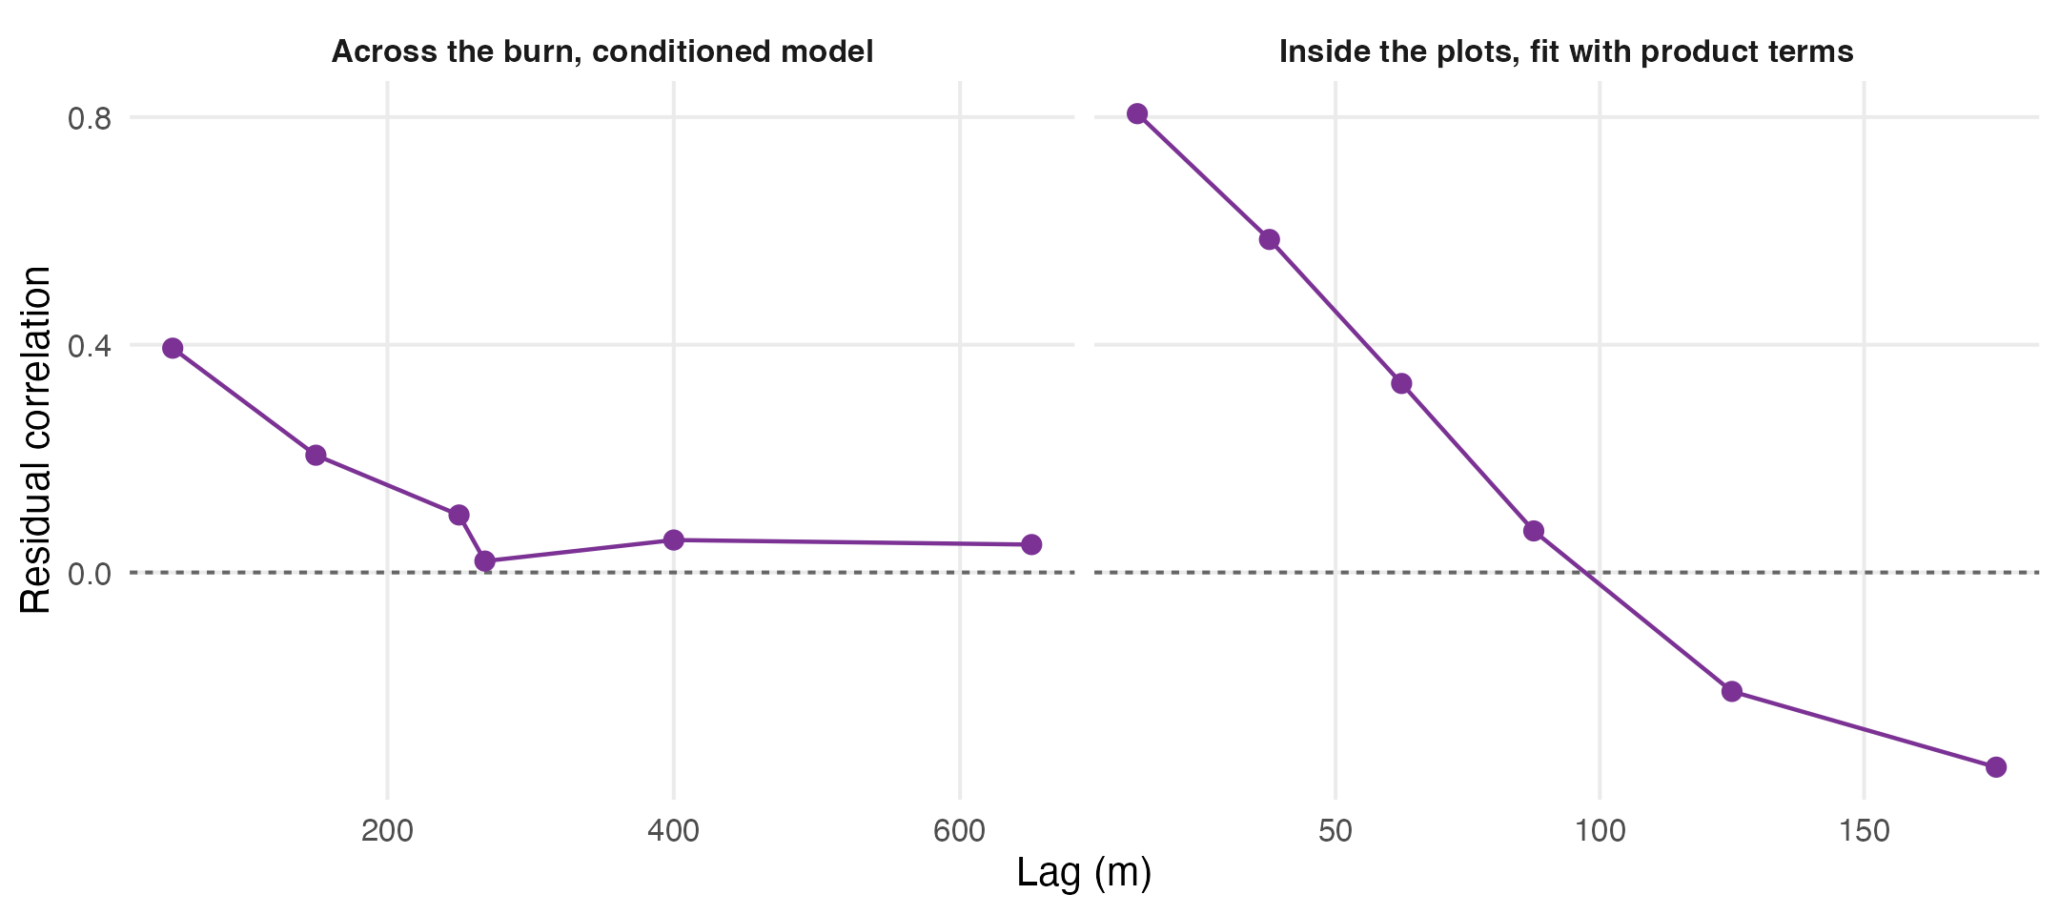
Figure 5: Residual dependence at the two scales the study works at. Left, the conditioned model of Section 4 across the burn, where dependence has largely decayed by 500 m. Right, the fit with product terms over the quadrature points inside the regeneration plots, where it has decayed by about 100 m. The two panels are the same obstacle two orders of magnitude apart, and each sets the block sizes tried at its own scale.
Dependence runs at 0.806 inside 25 m and is still 0.332 between 50 and 75 m, crossing zero at around 100 m. A block that contains it must therefore be at least 75 to 100 m on a side, and a 200 m plot affords few of those. That collision is the same one Section 4.4 met at landscape scale, arriving again two orders of magnitude down.
pp_boot <- function(X, side_m, seed = 11) {
ids <- split(seq_len(nrow(PP)), paste(PP$x %/% side_m, PP$y %/% side_m))
K <- length(ids)
set.seed(seed)
M <- vapply(seq_len(B_BOOT),
function(b) pfit(X, unlist(ids[sample.int(K, K, TRUE)], use.names = FALSE)),
numeric(ncol(X)))
ci <- apply(M, 1, quantile, c(0.025, 0.975), na.rm = TRUE)
tibble(Term = colnames(X), Lower = ci[1, ], Upper = ci[2, ], K = K,
Usable = apply(M, 1, function(v) sum(is.finite(v))))
}
PP_SHOWN <- c("MPB_G", "MPB_R", "Fire_H", "Fire_L", PRODT)
PPB_RAW <- bind_rows(lapply(PP_SWEEP, function(m)
pp_boot(X_PROD, m) |> filter(Term %in% PP_SHOWN) |> mutate(`Block side (m)` = m)))
PPB <- PPB_RAW |>
transmute(`Block side (m)`, Blocks = K, Term,
Estimate = round(B_PROD[Term], 3),
Interval = ci_txt(Lower, Upper),
` ` = ifelse(clears(Lower, Upper), "clears zero", "spans zero"))
invisible(keep(PPB, "fig-interaction"))
## The published likelihood's own interval, drawn beside the block intervals so
## the comparison the paper rests on is one figure rather than two tables.
## Design-matrix column names are not axis labels. Written once here and reused
## by the verdict chunk below, so the figure and the prose cannot disagree.
PP_WORDS <- c(MPB_G = "grey attack", MPB_R = "red attack",
Fire_H = "high severity", Fire_L = "low severity")
pp_label <- function(term) {
parts <- strsplit(term, ":", fixed = TRUE)
vapply(parts, function(v) {
lab <- paste(PP_WORDS[v], collapse = " by ")
paste0(toupper(substring(lab, 1, 1)), substring(lab, 2))
}, character(1))
}
SRC <- c("Poisson likelihood", paste(PP_SWEEP, "m blocks"))
PPF <- bind_rows(
tibble(Term = PP_SHOWN, Lower = B_PROD[PP_SHOWN] - 1.96 * SE_PROD[PP_SHOWN],
Upper = B_PROD[PP_SHOWN] + 1.96 * SE_PROD[PP_SHOWN], Source = SRC[1]),
PPB_RAW |> transmute(Term, Lower, Upper,
Source = paste(`Block side (m)`, "m blocks"))) |>
mutate(Estimate = B_PROD[Term],
Source = factor(Source, levels = SRC),
Kind = factor(ifelse(grepl(":", Term), "Product terms", "Main effects"),
levels = c("Main effects", "Product terms")),
Term = factor(pp_label(Term), levels = rev(pp_label(PP_SHOWN))))
FIG_INT <- ggplot(PPF, aes(Estimate, Term, colour = Source)) +
geom_vline(xintercept = 0, linetype = "22", colour = "grey40") +
geom_linerange(aes(xmin = Lower, xmax = Upper),
position = position_dodge(width = 0.75), linewidth = 0.45) +
geom_point(position = position_dodge(width = 0.75), size = 1.3) +
scale_colour_manual(values = c("#b2182b", "#c6dbef", "#6baed6", "#2171b5", "#08306b"),
name = NULL) +
facet_grid(Kind ~ ., scales = "free_y", space = "free_y") +
guides(colour = guide_legend(nrow = 1, reverse = FALSE)) +
labs(x = "Coefficient", y = NULL) +
theme(legend.position = "bottom", panel.grid.major.y = element_blank(),
strip.text.y = element_text(face = "bold", size = 8, angle = -90))
INT_PATH <- file.path("..", "03.outputs", "PNG", "fig-interaction.png")
ggsave(INT_PATH, FIG_INT, width = 7.4, height = 4.4, dpi = 300, bg = "white")
knitr::include_graphics(INT_PATH)
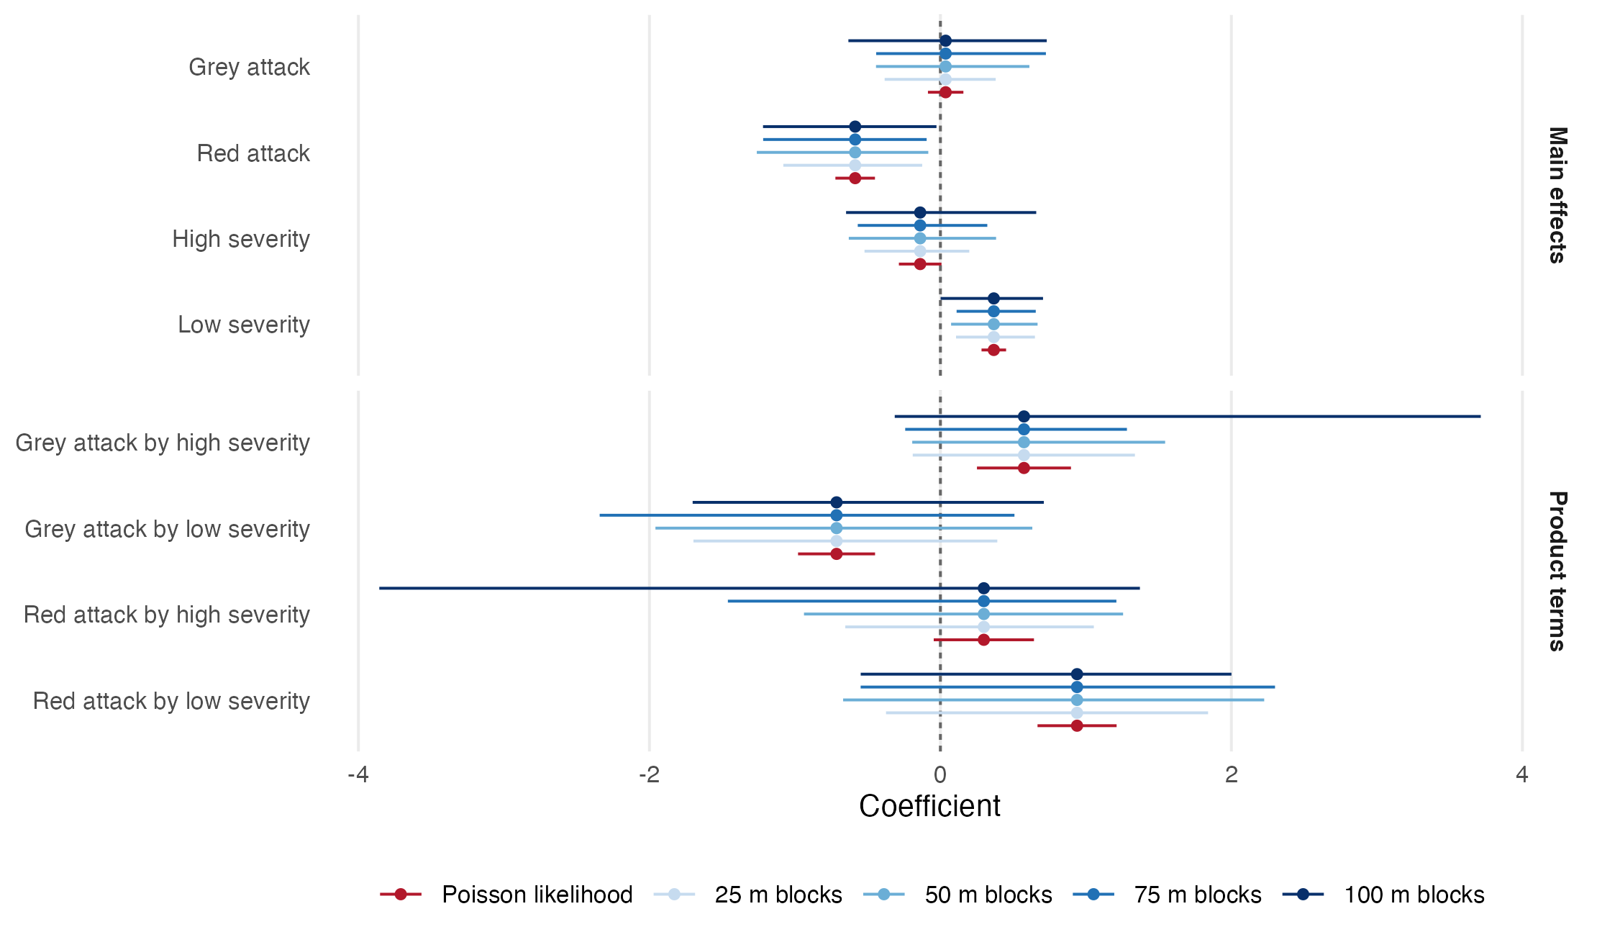
Figure 6: The four product terms and the main effects they modify, under the Poisson likelihood the published model is fitted with and under a spatial block bootstrap across block sizes spanning the residual range. The estimate is the same in every case; only the interval changes. Three of the four product terms exclude zero under the Poisson likelihood and none excludes it at any block size.
## Let the sweep state the conclusion. Asserting one that a refit could
## invalidate is the error sec-blocks records having made once already.
PROD_ROWS <- PPB_RAW |> filter(Term %in% PRODT)
PROD_CLEAR <- sum(clears(PROD_ROWS$Lower, PROD_ROWS$Upper))
MAIN_KEEP <- PPB_RAW |> filter(!Term %in% PRODT) |>
group_by(Term) |> summarise(all_clear = all(clears(Lower, Upper)), .groups = "drop") |>
filter(all_clear) |> pull(Term)
MAIN_WORDS <- paste(tolower(pp_label(MAIN_KEEP)), collapse = " and ")
## The block sizes the correlogram actually licenses, which is not all of the
## sizes tried. Quoting the full sweep's block counts would credit the study with
## the 25 m run's 234 blocks, and a 25 m block does not contain the dependence.
PP_OK <- PP_SWEEP[PP_SWEEP >= 75]
PP_OK_K <- PPB_RAW |> filter(`Block side (m)` %in% PP_OK) |>
distinct(`Block side (m)`, K) |> arrange(desc(K))
PP_OK_TXT <- paste(sprintf("%d at %d m", PP_OK_K$K, PP_OK_K$`Block side (m)`),
collapse = " and ")
WIDEN <- PPB_RAW |>
mutate(naive = 2 * 1.96 * SE_PROD[Term], ratio = (Upper - Lower) / naive) |>
summarise(lo = min(ratio), hi = max(ratio))
## The abstract lives in the YAML, where an inline `r` expression does not run, so
## its five quantities are the only hard-coded numbers in the document. They are
## asserted here instead: a refit that moves any of them fails the render rather
## than leaving the abstract quietly contradicting the results.
stopifnot(sprintf("%.3f", MOD_ADJ) == "0.416",
sprintf("%.1f", WIDEN$lo) == "2.4",
sprintf("%.1f", WIDEN$hi) == "7.6",
nrow(PROD_ROWS) == 16,
PROD_CLEAR == 0)
Not one of the 16 product-term intervals excludes zero. Across four block sizes and 4 product terms the count that clears is 0. The estimates have not moved, because the estimates are not what was wrong; the intervals have widened by a factor of 2.4 to 7.6 against the naive Poisson intervals of Table 12, and that factor is the whole of the difference between an interaction that looks overwhelming and one that is not there.
What survives is thin and worth stating precisely. The only terms among those shown whose intervals exclude zero at every block size are low severity and red attack. Neither is a product term. The regeneration data support main effects for red-stage beetle attack and low burn severity, and support no statement at all about the two agents acting together.
This is not a demonstration that the agents do not interact. It is a demonstration that these data cannot tell. Three plots totalling 12.7 ha afford 36 at 75 m and 27 at 100 m across the block sizes the residual range permits, and a product term asks the data to resolve a difference of differences across four severity-by-attack combinations on that footprint. The published likelihood answers the question confidently because it counts 3,866 seedlings as 3,866 independent pieces of evidence. They are not.

Discussion
Two questions were asked. Neither returned the answer it was posed to find, and the reasons are different in kind.

Principal findings
Beetle and fire cannot be compared across the fire perimeter here, because the surfaces that would do it stop at the perimeter. The annual classifications from which every local beetle surface descends carry nodata across almost all of the unburned forest, and carried it before any classification that used them was run. The consequence is not a caveat: a contingency table built across the boundary reports attack rising from a fraction of a per cent in unburned forest to a fifth at moderate severity, and measures the mask. The provincial Aerial Overview Survey, never clipped, finds attack outside the perimeter at a rate no lower than inside it.
Within the burn the severity gradient is real and narrow. Three records that do not share a measurement pathway agree that attack peaks at moderate severity, and conditioning on lodgepole cover and elevation attenuates that peak by about two fifths without removing it. The fall at high severity is not supported in any specification, so the non-monotone shape is a claim these data carry at its peak and not at its fall.
The beetle by fire interaction is not supported. Through the likelihood the parent study uses it is emphatic: a likelihood ratio statistic of 99.2 on 4 degrees of freedom and three of four product terms excluding zero. Under inference accounting for the clustering of the seedling pattern, every product term spans zero at every block size tried. The estimates do not move; only the intervals do, by a factor of 2.4 to 7.6, and that factor is the whole distance between a confirmed interaction and none.

Inferential generality
The parent study’s abstract describes the additive effects of increasing beetle to fire disturbance interactions. Its model has no product term. This paper set out to close that gap by adding one, and found that the data cannot support a product term either way. That is a more useful outcome than either of the two the study was designed to produce, because it locates the problem in the inference rather than in the ecology.
The mechanism is worth stating plainly, because it is not specific to this landscape. A point process trend fitted by the Berman-Turner device is a weighted Poisson regression (Berman and Turner 1992; Baddeley and Turner 2000), and a Poisson likelihood treats every seedling as an independent piece of evidence about the covariates. The parent study devotes two figures and 999 Monte Carlo simulations to establishing that the seedling pattern is not independent: it reports significant clustering in every species examined, which is the expected result for conifer regeneration and not a defect (Murphy et al. 2026). Those two facts sit in the same paper, and the second invalidates the standard errors the first is reported alongside. The residual correlogram of Figure 5 reaches the same verdict from inside the model, with dependence of 0.806 within 25 m.
This is not an unusual error and it is not a careless one: clustered point patterns are routinely fitted this way and the software makes the Poisson path the path of least resistance. What makes it consequential is the size of the correction. A misspecified likelihood does not usually move a coefficient, it moves the interval around it, and the interval is what the claim rests on.
The caution this implies is not new, and the more careful practice already exists. Modelling conifer regeneration after a large mixed-severity fire, Donato et al. (2009) excluded from their candidate set any model carrying more than five predictors or any interaction term, on the stated ground that the sample was too modest to support them, and reported relative importance among additive predictors instead. That is a judgement made in advance, on a study of comparable design and larger extent, and it reaches the conclusion this paper reaches by measurement. The difference is instructive rather than flattering to us: a product term excluded on principle costs nothing and leaves no false claim behind, whereas a product term admitted and then read through the wrong likelihood produces a confident number that has to be withdrawn later. The result reported here is therefore better understood as a quantification of a discipline that this literature already exercises than as an objection to one study that failed to.

Extent constraints
Every result here is bounded by an extent chosen by a disturbance rather than by a design. The burn is about eight square kilometres and the regeneration plots total 12.7 ha inside it: the ground on which beetle and fire co-occur at all, so not an arbitrary choice, but not a neutral one either.
The consequences run the same way at both scales. Across the burn, lodgepole cover and elevation correlate at 0.52 and cannot be separated, where the companion study distinguishes them because 1,776 m of relief contains pine-poor ground at every height (Murphy 2026a). The fitted elevation optimum lands at 503 m, far below the range the clip spans, so an analyst working only here would report attack rising with elevation without limit; the landscape-scale hump is not contradicted but out of view.
The same collision governs the inference. A block bootstrap needs blocks large enough to contain the dependence and numerous enough to resample, and at both scales the extent caps the first before the second is comfortable: a 500 m block holds most of the dependence across the burn and affords 27, where 1 km would afford eight, and inside the plots the residual range demands 75 to 100 m and the plots afford 36 at 75 m and 27 at 100 m. This is the paper’s subject matter arriving in its own methods: the extent that makes a compound-disturbance question askable is the extent that decides how firmly it can be answered.

Limitations
Four of this study’s five results are negative, and they are reported at the same length and in the same register as the one that is not. That is a deliberate choice rather than an apology. The same practice is visible in recent work on burn severity in this literature: Estabrook et al. (2025) report a severity model with acceptable discrimination and then state plainly that the map built from it performed poorly, with a residual spatial structure their own diagnostic detected. A negative applied result reported clearly is more useful than a positive one reported without its diagnostics, and the limitations below are set out in that spirit.
The interaction result is a null, and nulls have a floor. Nothing here shows that beetle mortality and burn severity do not interact. It shows that 3,866 seedlings across 12.7 ha, clustered as this pattern is, cannot resolve a difference of differences across four severity-by-attack combinations. A larger or better distributed sample could return a different answer, and this study offers no estimate of how much larger.
Question A is answered in a reduced form. The within-burn gradient is not the question the compound-disturbance literature asks, which is whether beetle-killed stands burn differently from stands that were not attacked. Recovering that comparison means rebuilding the classification over the unclipped landscape, a reprocessing task that re-treads the parent study’s published methods.
Two beetle surfaces disagree and only one is documented. The corrected grey-stage union is preferred throughout: three times denser than the published red-stage surface, observed throughout the perimeter, and derived by a script that survives (Murphy 2026b). The red-stage surface is a substitution for a layer absent from the parent repository and searched for without success.
The severity reference category is inherited, not chosen. The published specification carries indicators for high and low severity only, so moderate severity is pooled with unburned and unclassified ground into a reference that is 82 per cent moderate, the class carrying the most beetle attack. It is reproduced rather than repaired, because the object was to test the published model rather than replace it, but no fire coefficient here means quite what its label says.
The provincial survey is a coarse instrument, its polygons sketched from an aircraft at a mapping scale far coarser than 30 m. It is used only as a check on whether ground outside the perimeter carries attack at all, which it can answer, and not as a measurement of severity, which it cannot.

Research priorities
Three things, in descending order of value against cost. The interaction test should be repeated where extent is not the binding constraint, which given the dependence range measured here means a distributed plot network rather than three contiguous plots. The published point process results should be reported with intervals that respect the clustering, which is inexpensive because the estimates are unchanged, and which on the evidence of Figure 6 leaves two main effects standing. And recovering question A in its original form requires rebuilding the beetle classification over the unclipped landscape, which is worth doing only if the Landsat archive is being revisited anyway.

Conclusions
Compound disturbance is described as an interaction far more often than it is tested as one, and the gap between the description and the test is where this study lives.
Three findings, stated at the confidence the data support.
- A provenance result. The beetle surfaces underlying the parent study stop at the fire perimeter, in the source files, before classification. Any comparison of beetle attack across that boundary measures the clip and not the forest. This is checkable in any study that inherits rasters it did not build, and it is cheap to check.
- A narrow ecological result. Inside the burn, beetle attack is elevated at moderate severity relative to low, by 0.416 in log-odds after conditioning on host and elevation, and it clears a spatial block bootstrap interval at every block size the extent supports. Attack at high severity is not distinguishable from attack at low severity in any specification.
- A negative result about the interaction, and a positive one about why. The beetle by fire product term is decisive under the published Poisson likelihood and absent under inference that accounts for the clustering the parent study itself documents. The coefficients are identical either way. Only the intervals differ, and they differ by a factor of 2.4 to 7.6.
The title of this paper is a description of the parent study and, on this evidence, a recommendation. Beetle and fire were modelled additively there. Nothing found here supports modelling them any other way with data of this extent, and the apparent support for doing so came from a likelihood that counted clustered seedlings as independent observations. The honest summary of a compound-disturbance interaction in this landscape is that it has not been demonstrated, that these data cannot demonstrate it, and that the confidence with which it can appear to have been demonstrated is the finding most worth carrying elsewhere.

Author statements
Author contribution statement. SM: conceptualisation, methodology, software, formal analysis, data curation, writing (original draft), writing (review and editing), visualisation.
Competing interests statement. The author is also an author of Murphy et al. (2026), the study re-analysed here, and declares no other competing interests.
Funding statement. The author declares no specific funding for this work.
Data availability statement. The raster surfaces analysed here are held by the parent study (Murphy et al. 2026) and are not redistributed with this manuscript. The corrected grey-stage package of 2 June 2026 is documented in (Murphy 2026b). The provincial Aerial Overview Survey is open under the Open Government Licence for British Columbia (Province of British Columbia, Ministry of Forests 2026). The executable source document that produced every number, table and figure in this paper, together with the derived inputs needed to run it, will be deposited on acceptance and the identifier added here.
Acknowledgements. No generative artificial intelligence was used to produce the scientific content, the analysis or the results of this manuscript.

References
Baddeley, A., and Turner, R. 2000. Practical maximum pseudolikelihood for spatial point patterns. Australian & New Zealand Journal of Statistics 42(3): 283–322. doi:10.1111/1467-842X.00128.
Bansal, S., Jochum, T., Wardle, D.A., and Nilsson, M.-C. 2014. The interactive effects of surface-burn severity and canopy cover on conifer and broadleaf tree seedling ecophysiology. Canadian Journal of Forest Research 44(9): 1032–1041. doi:10.1139/cjfr-2014-0112.
Berman, M., and Turner, T.R. 1992. Approximating point process likelihoods with GLIM. Journal of the Royal Statistical Society Series C: Applied Statistics 41(1): 31–38. doi:10.2307/2347614.
Donato, D.C., Fontaine, J.B., Campbell, J.L., Robinson, W.D., Kauffman, J.B., and Law, B.E. 2009. Conifer regeneration in stand-replacement portions of a large mixed-severity wildfire in the Klamath–Siskiyou Mountains. Canadian Journal of Forest Research 39(4): 823–838. doi:10.1139/X09-016.
Estabrook, T., Fried, J., Xi, W., Su, H., and Zhang, J. 2025. Linking burn severity to pre-fire forest structure and weather on the Dixie fire offers potential to map prospective burn severity. Canadian Journal of Forest Research 55: 1–20. doi:10.1139/cjfr-2024-0305.
Hart, S.J., Schoennagel, T., Veblen, T.T., and Chapman, T.B. 2015. Area burned in the western United States is unaffected by recent mountain pine beetle outbreaks. Proceedings of the National Academy of Sciences 112(14): 4375–4380. doi:10.1073/pnas.1424037112.
Harvey, B.J., Donato, D.C., and Turner, M.G. 2014. Recent mountain pine beetle outbreaks, wildfire severity, and postfire tree regeneration in the US Northern Rockies. Proceedings of the National Academy of Sciences 111(42): 15120–15125. doi:10.1073/pnas.1411346111.
Jenkins, M.J., Page, W.G., Hebertson, E.G., and Alexander, M.E. 2012. Fuels and fire behavior dynamics in bark beetle-attacked forests in Western North America and implications for fire management. Forest Ecology and Management 275: 23–34. doi:10.1016/j.foreco.2012.02.036.
Krawchuk, M.A., Meigs, G.W., Cartwright, J.M., Coop, J.D., Davis, R., Holz, A., Kolden, C., and Meddens, A.J.H. 2020. Disturbance refugia within mosaics of forest fire, drought, and insect outbreaks. Frontiers in Ecology and the Environment 18(5): 235–244. doi:10.1002/fee.2190.
Kulakowski, D., and Veblen, T.T. 2006. The effect of fires on susceptibility of subalpine forests to a 19th century spruce beetle outbreak in western Colorado. Canadian Journal of Forest Research 36(11): 2974–2982. doi:10.1139/x06-182.
Magnussen, S., Breidenbach, J., and Mauro, F. 2017. The challenge of estimating a residual spatial autocorrelation from forest inventory data. Canadian Journal of Forest Research 47(11): 1557–1566. doi:10.1139/cjfr-2017-0247.
Meigs, G.W., Kennedy, R.E., and Cohen, W.B. 2011. A Landsat time series approach to characterize bark beetle and defoliator impacts on tree mortality and surface fuels in conifer forests. Remote Sensing of Environment 115(12): 3707–3718. doi:10.1016/j.rse.2011.09.009.
Meyer, M.D., Bulaon, B., MacKenzie, M., and Safford, H.D. 2016. Mortality, structure, and regeneration in whitebark pine stands impacted by mountain pine beetle in the southern Sierra Nevada. Canadian Journal of Forest Research 46(4): 572–581. doi:10.1139/cjfr-2015-0464.
Murphy, S. 2026a. Topographic refugia from mountain pine beetle, and why terrain-derived wind surfaces cannot find them at small extents.
Murphy, S. 2026b, June. Memo: Grey-stage raster derivation was wrong; corrected here.
Murphy, S., Leslie, A., Wilson, J., and Banks, L.K. 2026. Spatial patterns of conifer regeneration following mountain pine beetle outbreak (dendroctonus ponderosae) and mixed-severity wildfire: A point process model of disturbance interactions in the southern Selkirk Mountains, British Columbia. Forest Ecology and Management 618: 123985. doi:10.1016/j.foreco.2026.123985.
Province of British Columbia, Ministry of Forests. 2026. Pest infestation polygons (Aerial Overview Survey). BC Data Catalogue, Open Government Licence British Columbia.
Simard, M., Romme, W.H., Griffin, J.M., and Turner, M.G. 2011. Do mountain pine beetle outbreaks change the probability of active crown fire in lodgepole pine forests? Ecological Monographs 81(1): 3–24. doi:10.1890/10-1176.1.
Stevens-Rumann, C.S., Prichard, S.J., Strand, E.K., and Morgan, P. 2016. Prior wildfires influence burn severity of subsequent large fires. Canadian Journal of Forest Research 46(11): 1375–1385. doi:10.1139/cjfr-2016-0185.
Talucci, A.C., and Krawchuk, M.A. 2019. Dead forests burning: The influence of beetle outbreaks on fire severity and legacy structure in sub-boreal forests. Ecosphere 10(5): e02744. doi:10.1002/ecs2.2744.
Wulder, M.A., White, J.C., Bentz, B., Alvarez, M.F., and Coops, N.C. 2006. Estimating the probability of mountain pine beetle red-attack damage. Remote Sensing of Environment 101: 150–166. doi:10.1016/j.rse.2005.12.010.

